**Master’s Thesis**

Department of Ecology, Evolution, and Organismal Biology

College of Science and Math

Kennesaw State University

|  |  |
| --- | --- |
| Author: Zach Peagler | Supervisor: Mario Bretfeld, PhD |
| Email: [zpeagler@students.kennesaw.edu](mailto:zpeagler@students.kennesaw.edu) | **Email**: [mbretfel@kennesaw.edu](mailto:mbretfel@kennesaw.edu) |
| Phone: 770-893-8365 | **Phone**: 470-578-3275 |

**Committee:**

Dr. Christopher Cornelison, Kennesaw State University

Dr. Kyle Gabriel, Kennesaw State University

Dr. Matthew Weand, Kennesaw State University

**TITLE**

Optimization of biostimulant encapsulation and its efficacy on tomato

**ABSTRACT**

Finding sustainable ways to feed an ever-expanding population while reducing our reliance on synthetic fertilizers is of the utmost importance to humanity. To accomplish this, new sustainable agriculture techniques are required. One technique that has garnered attention is the use of plant growth promoting bacteria (PGPB) biostimulants. These microorganisms operate through various modes of action, and the inoculation profile and load can be tailored to suit the target crop and inoculation method and have been shown to provide tangible benefits to the plant ranging from increased stress tolerance to reduced nutrient requirements. However, while commercial biofertilizers do currently exist, their widespread implementation has been hindered by inconsistent field results and a lack of economic feasibility stemming from sub-optimal carrier materials. One promising avenue is the use of an encapsulating carrier material, such as chitosan or alginate. These biopolymers can form inoculated granules capable of delivering PGPB and arbuscular mycorrhizal fungi (AMF) that promote plant growth, stress tolerance, and produce shelf life.

**Key words**: biostimulant, PGPB, AMF, chitosan, alginate, encapsulation, desiccation, tomato

**CONTENTS**

I. Background . . . . . . . . . . . . . . . . . . . . . . . . . . . . . . . . . . . . . . . . . . . . . . . . . . . . . . . . . . . . . . . . . . . . . . . . . . . 2

II. Hypotheses/Objectives . . . . . . . . . . . . . . . . . . . . . . . . . . . . . . . . . . . . . . . . . . . . . . . . . . . . . . . . . . . . . . . . . 5

III. Methodology . . . . . . . . . . . . . . . . . . . . . . . . . . . . . . . . . . . . . . . . . . . . . . . . . . . . . . . . . . . . . . . . . . . . . . . . 6

IV. Results . . . . . . . . . . . . . . . . . . . . . . . . . . . . . . . . . . . . . . . . . . . . . . . . . . . . . . . . . . . . . . . . . . . . . . . . . . . . . 9

V. Discussion . . . . . . . . . . . . . . . . . . . . . . . . . . . . . . . . . . . . . . . . . . . . . . . . . . . . . . . . . . . . . . . . . . . . . . . . . . . 12

VI. Integrative Aspects . . . . . . . . . . . . . . . . . . . . . . . . . . . . . . . . . . . . . . . . . . . . . . . . . . . . . . . . . . . . . . . . . . . 12

VII. References . . . . . . . . . . . . . . . . . . . . . . . . . . . . . . . . . . . . . . . . . . . . . . . . . . . . . . . . . . . . . . . . . . . . . . . . . 13

VIII. Figures . . . . . . . . . . . . . . . . . . . . . . . . . . . . . . . . . . . . . . . . . . . . . . . . . . . . . . . . . . . . . . . . . . . . . . . . . . . . 18

1. **BACKGROUND**

The human population has recently surpassed 8 billion and is expected to exceed 9.8 billion by 2050 (UN, 2017), and this expanding population requires an expanding food supply, with food production projected to increase by 70% from 2005 to 2050 (Noel *et al.*, 2015). The predominant approach to maximizing crop yield is the use of synthetic fertilizers, chemically manufactured sources of nitrogen, phosphorous, and potassium, which have had environmental impacts including groundwater contamination, water body eutrophication, ecosystem disruption, greenhouse gas emission, and stratospheric ozone depletion (Conley *et al.,* 2009; Rosa & Gabrielli, 2022). These synthetic fertilizers are also expensive, accounting for 20% to 36% of a farm’s budget, with this cost nearly tripling in the past two years (Schnitkey *et al.,* 2021; Brownlie *et al.,* 2023). A recent report has stated that microbial fertilizers have the potential to generate billions in social benefits be reducing the emissions from synthetic fertilizers (UC Innovation Commission, 2023). Sustainable alternative solutions to synthetic fertilizers are necessary to alleviate the environmental and economic toll of synthetic fertilizers while also feeding an expanding human population (Fitter, 2012).

One possible solution is the use of biostimulants, which include microorganisms such as plant growth promoting bacteria (PGPB), arbuscular mycorrhizal fungi (AMF), and biologically derived compounds (humic acid, biochar, kelp extract, etc.) that promote plant growth, improve crop quality and yield, and increase plant stress tolerance. Applications of microbial biostimulants have been found to reduce fertilizer requirements by 25% and increase crop yield by 17.9% on average (Adesemoye & Kloepper, 2009 ; Li *et al.,* 2022). While biostimulants show promise as a potential alternative for or amendment to synthetic fertilizers, microbial biostimulants are currently held back from widespread implementation due to logistical constraints arising from sub-optimal carrier materials and a lack of awareness from farmers. Carrier materials are necessary for inoculant production, as without a carrier most PGPB populations decline rapidly after inoculation (Bashan *et al.,* 2014).

Current carrier materials can be classified as either wet or dry, with dry inoculants (peat, clay, lignite, etc.) having longer shelf lives, lower contamination risk, and cheaper storage and transportation costs than liquid inoculants (Bashan *et al.,* 2014). Dry carriers can be applied directly to the soil or dissolved in water for a foliar inoculation, while wet carriers are applied almost exclusively as a foliar inoculation. In a broad review (Li *et al.,* 2022), soil inoculation has generally been shown to be more effective at increasing yield than foliar inoculation. Dry inoculants have shown inconsistent results in the field, shown unreliable performance in different environments, are often expensive, and are easily contaminated, preventing their implementation.(Bashan *et al.,* 2014) To achieve the next step towards widespread biostimulant use, inoculation methods must prove that they can reliably maintain microbial viability and efficacy in the field after long-term storage and exposure to environmental stressors, all while being cheap, safe, and easy to produce and use (Bashan *et al.,* 2014).

A new inoculation method that has shown promise is encapsulation, the process of immobilizing biostimulants in droplet-derived granules which can then be dried for storage and transport. Encapsulation requires an encapsulation base and a cross-linker. One encapsulation base that has shown great promise is chitosan, itself a biostimulant that has been shown to increase plant growth and stress tolerance in tomato plants and can entrap microbial biostimulants in granules (Chanratana *et al.,* 2019). Another encapsulation base, alginate, is also a biostimulant that can entrap microbes (Joe *et al.,* 2012). Encapsulation has been shown to increase microbial viability in the presence of desiccation stress, as well as allow for a controlled release of the inoculant (Schoebitz *et al.,* 2013). Studies have shown that both bacteria and fungi can be encapsulated and maintain their viability, but many of these studies have been done with alginate rather than chitosan, despite chitosan having been shown to be more effective at maintaining microbial viability than alginate (Declerck, 1996; Bashan & Gonzalez, 1999; Chanratana *et al.,* 2018). Studies also suggest that encapsulation is necessary for PGPBs and AMFs to achieve maximum effectiveness and viability while also being practical for implementation by farmers (Bashan *et al.,* 2014; Berninger *et al.,* 2018).

Chitosan, a biopolymer derived from crustacean shells and fungi, is made up of repeating N-acetylated glucosamine units, generally 85% deacetylated. When combined with an acid, the deacetylated amine groups protonate, becoming NH3+. This allows the amine groups to act as binding sites for negatively charged functional groups, like those found on cross-linking agents. The acid used to protonate the chitosan, as well as the degree of protonation, have large impacts on the final granule formation and strength, and are likely to alter the microbial release rate (Fanaee & Filiaggi, 2023). Acetic acid is commonly used as a protonation agent throughout the literature (Chanratana *et al.,* 2018; Fanaee & Filiaggi, 2023). No tests have been done with organic acids besides acetic acid to protonate chitosan, and protonation with other organic acids (formic, propionic, butyric, etc.) may prove useful in altering granule morphology, water adsorption, and release characteristics. The degree of protonation affects the conformation the polymer takes, as shown in **Figure 1**, which will also likely affect granule characteristics (Dey *et al.,* 2016). Sterilization of encapsulation components is important to remove any possible prior microbial contamination, and this acid protonation makes sterilization difficult, as the protonated chitosan cannot be autoclaved without undergoing chain fragmentation, as at elevated temperatures the chitosan is likely to undergo acid hydrolysis, as shown in **Figure 2.** This means that the production of chitosan-encapsulated inoculants will need to either find an order of operations that does not autoclave protonated chitosan or find an alternate method for the sterilization of the protonated chitosan solution. Finding an order of operations to not autoclave chitosan may prove challenging, as chitosan needs to be in an acidic solution to be soluble in water.

|  |
| --- |
|  |
| **TEMPORARY Figure 1. Protonation dependent chitosan conformations** |

|  |
| --- |
|  |
| **TEMPORARY Figure 2. Temperature dependent reaction of chitosan with HCl** |

Alginate, a biopolymer derived from algae,is made up of randomly distributed β-D-mannuronate and α-L-guluronate units. Unlike chitosan, alginate does not require a protonation step prior to encapsulation and does not suffer from chain fragmentation when autoclaved in solution, making it significantly easier to process, while eliminating the cost of the acid. It is also an order of magnitude less expensive than chitosan. The literature surrounding the use of alginate and chitosan is unclear as to which is better as an encapsulation agent for microbial biostimulant immobilization.

As for cross-linking agents, the inorganic sodium tripolyphosphate (TPP) has traditionally been successful in forming inoculated granules with chitosan, and is gentle and non-toxic, making it ideal for inoculant production (Chanratana *et al.,* 2019). The capture efficiency of some, but not all, bioactive compounds depend on the cross-linker's pH, and on the understanding under what conditions the cross-linker enables high efficiency biostimulant capture is of high importance to inoculant production (Ghanem & Skonberg, 2001).

Desiccation is necessary for the successful commercialization of an encapsulated microbial biostimulant. Desiccation can increase the encapsulated microbial density, stop bacterial metabolism, and lower transportation and storage costs, but desiccation is also known to be one of the main causes of unviability in inoculants (Meng *et al.,* 2008; Berninger *et al.,* 2018). Microbes are not inherently tolerant to desiccation. Desiccation induces oxidative stress from ROS buildup and is known to damage membranes, proteins, and DNA of cells, with protein damage thought to be the leading cause of desiccation-induced cell death (Franca *et al.,* 2007; Tapia & Koshland, 2014). Previously, desiccation has been shown to induce protein aggregation, which subsequently induces molecular crowding, lipid peroxidation, ROS production, and leakage in the cell (Wang *et al.,* 2012; Bednarska *et al.,* 2013; Tapia & Koshland, 2014). In addition, the removal of water can cause protein misfolding and changes to the protein’s structure, which can lead to cell damage.

Despite multiple endogenous mechanisms for dealing with desiccation stress, finding methods to increase desiccation tolerance in microbes is key to successful inoculant production (Greffe & Michiels, 2020). Air drying is a simple technique that involves exposing the inoculated granules to air at ambient pressure or under a vacuum (Santivarangkna *et al.,* 2007), and is highly effective at a low cost. There are many different approaches to air drying, ranging from simple airtight containers filled with a desiccant, such as silica gel, all the way to complex vacuum heated chambers with shaking plates (Berninger *et al*., 2018). The inoculant density heavily influences desiccation time, with more densely packed inoculants requiring longer drying times. Air drying also enables the microbes in the inoculant to produce endogenous responses to drought stress, increasing their viability.

In addition to questions associated with developments of inoculated granules, the timing at which the inoculants are introduced to the plant has been shown to greatly influence the inoculation efficiency, with some strains showing increased performance with seed inoculation, and others showing increased performance with soil inoculation (Ciccillo *et al.,* 2002; Afzal *et al.,* 2011). Biotic factors also influence inoculation efficiency, and can be inhibited by factors like microbiome priority effects and niche overlap (Verbruggen *et al.,* 2012).

In summary, microbial viability and efficacy following encapsulation-desiccation and subsequent storage hinge upon many factors such as encapsulation base, cross-linker, and dropwise addition conditions, as well as desiccation method, osmoprotectant addition, storage conditions, and more. There are many gaps in the literature surrounding chitosan encapsulation that need to be filled before chitosan can reasonably be considered for industrial commercialization. There have been no studies done on the effectiveness of chitosan encapsulated-desiccated granules in maintaining microbial viability after extended storage and their subsequent effect on plants, especially in low-water intensity farming. Low-water intensity farming reduces the potential for nutrient runoff and produces greater yields, however this often comes at the cost of crop quality (Stamatakis *et al,* 2003). Salt stress produces greater crop quality, often at the cost of yield by inducing blossom-end rot, which results in unmarketable fruit (Rosadi *et al.,* 2014). By combining these techniques with the application of biostimulants, it should be possible to offset the quality-quantity tradeoff, achieving a large yield of high quality fruit. Multiple studies have shown that combinations of PGPBs are more effective than lone PGPBs (Madhaiyan *et al.,* 2009; ; He *et al.,* 2019). The exact biostimulant load depends on the target crop and soil conditions.

1. **HYPOTHESES/ OBJECTIVES**

**Objective 1.** Determine the effect of *M. oryzae* inoculation method on tomato plant growth and crop quality and yield.

**Hypothesis 1.1** – Because of the mass effect, combined soil and foliar *M. oryzae* application will increase salt stressed tomato fruit yield and fruit quality more than either soil or foliar inoculations.

**Objective 2 –** Determine the effect of BG inoculation timing on tomato plant growth and crop quality and yield.

**Hypothesis 2.1 –** Because of the priority effect and the mass effect, BGs with the full microbial consortium applied at both germination and transplantation will increase fluorescence parameters more than either germination or transplantation inoculations.

**Hypothesis 2.2 –** Because of the priority effect and the mass effect, BGs with the full microbial consortium applied at both germination and transplantation will increase tomato fruit yield and quality more than either germination or transplantation inoculations.

**Objective 3 –** Determine the effect of biostimulant inoculation method (liquid, BG, uninoculated granule) on plant growth and fluorescence parameters.

**Hypothesis 3.1 –** Because bacteria have been shown to increase plant growth and the encapsulation will aid in bacterial delivery, inoculation of tomato plants with BGs will increase plant growth and fluorescence parameters more than liquid inoculation and uninoculated granules.

**Objective 4 –** Determine the effect of polymer, inoculant, and decomposition media on the decomposition rate of BGs.

**Hypothesis 4.1 –** Because of the physical properties of alginate and chitosan, BGs made of alginate will decompose more quickly than BGs made of chitosan.

**Hypothesis 4.2 –** Because of the bacterial decomposition occurring inside the granules, inoculatedBGs will decompose more quickly than uninoculated BGs.

**Hypothesis 4.3 –** Because of the microbes in the soil aiding in granule breakdown, BGs decomposing in soil will break down more quickly than BGs decomposing in paper.

1. **METHODOLOGY**

**III.A. BGs**

**III.A.1. BG Creation**

The following microbes were used in a final microbial consortium, with emphasis on those that have already been proven to provide benefits to tomato plants. This combination of microorganisms (at 1x10^6 cfu/mL each) will be heretofore referred to as the microbial consortium.

*Azospirillum brasilense -* PGPB that benefits the plant via nitrogen fixation, siderophore production, and by increasing lateral root growth (Sahoo *et al*, 2014; Li *et al*, 2005), and has been shown to increase plant stress tolerance (Casanovas *et al*, 2002). It has been shown to increase crop yield and plant nitrogen, phosphorous, and potassium content (Askary *et al*, 2009). It has also been reported to work well with *Methylobacterium oryzae* (Madhaiyan *et al*, 2009).

*Azotobacter chroococcum -* PGPB that operates via nitrogen fixation, phosphate solubilization, and vitamin, indole acetic acid (IAA), gibberellin (GA), hydrogen cyanide (HCN), siderophore, and cytokinin (CK) production (Abd El-Fattah *et al*, 2013; Revillas *et al*, 2000; Wani *et al*, 2007). Shown to increase germination rates and aboveground biomass and crop quality and yield in maize (Zahir et al, 2005).

*Bacillus subtilis -* PGPB that has been shown to improve fruit quality and yield in tomato (Mena-Violante & Olalde-Portugal, 2007; Kokalis-Burelle *et al*, 2002) and shown to increase metabolite production (Sharaf-Eldin *et al*, 2008). Shown to solubilize phosphate, fix nitrogen, produce IAA, CK, GA, HCN, and antibiotics, as well as exhibiting phytase activity (Ahmad *et al,* 2008; Arkhipova *et al,* 2005; Yao *et al,* 2006). It has been used as a biocontrol agent against aphids and pathogenic bacteria (Kokalis-Burelle *et al,* 2002).

*Methylobacterium oryzae -* PGPB that has been shown to improve fruit quality and yield in tomato in both foliar and chitosan encapsulated inoculations (Chanratana *et al.,* 2019). Operates through phytohormone (auxin and cytokinin) production, stress reduction via ACC deaminase production, increased nutrient availability through nitrogen fixation, and as a biopesticide (Chauhan *et al*., 2015).

*Pseudomonas putida -* PGPB that increases plant growth by solubilizing phosphate and producing IAA and siderophores (Hariprasad & Niranjana, 2009). Shown to inhibit ethylene production (Mayak *et al,* 1999). Shown to significantly increase tomato fruit macro- and micronutrient content (He *et al,* 2019). Shown to increase potassium, magnesium, and calcium uptake and decrease sodium uptake (Yao *et al,* 2010). Also shown to increase root and shoot growth (Glick *et al,* 1997; Hall *et al,* 1996).

Biostimulant Granules (BGs) with chitosan were created by first autoclaving 250 mL of DI water, to which was added 5% chitosan (85% deacetylated), which was then protonated with 0.3 M HCl. A solution of 5% TPP was created, and both solutions were sterilized. Microbes collected in the stationary phase were added to 50 mL protonated chitosan aliquots at a concentration of 5x106 cfu/mL. Bacterial concentration was achieved by culturing bacteria in their respective media for 72 hours, taking measurements with a spectrophotometer at OD600, comparing that to a known calibration curve, and diluting accordingly. Inoculated aliquots were combined to form a single inoculated chitosan solution. This microbial consortium and chitosan mixture was then added to the TPP via dropwise addition using a peristaltic pump and a 2mm nozzle, with the TPP shaking at 60 rpm. After curing for 30 minutes, the granules were transferred to a vacuum desiccation chamber and allowed to dry for 24 hours at 30°C and 0.5 atm. The varying morphology in dried chitosan BGs created under the same conditions can be seen in **Figure 4.** A comparison of dried and undried chitosan BGs can be seen in **Figure 5.**

|  |
| --- |
|  |
| **TEMPORARY Figure 4.** Dried chitosan BGs 400x magnification. |

|  |
| --- |
|  |
| **TEMPORARY Figure 5.** Chitosan BGs during different stages of the drying process.  (update this figure to add a row below, showing alginate granules at different stages in the drying process.) |

To create BGs with alginate, a similar process was followed, but using 2% alginate as the encapsulation base and 2% calcium chloride as a cross-linker. Both solutions were prepared, then autoclaved, and from there made in exactly the same manner as the chitosan BGs.

BGs were not made in a biosafety cabinet, but on the lab bench with a Bunsen burner approximately 15 cm from the location of dropwise addition.

**III.A.2. BG Longevity Trial**

BGs with seven different inoculations (five treatments comprising single bacteria inoculation of each species mentioned above, one treatment containing every bacterium, and one control treatment without bacteria) were stored to assess their viability over time. Each sample contained 50g of BGs and were stored at three different temperature (-20, 4, 24°C). At set intervals (1 week, 1 month, 3 months, 6 months, 1 year) microbial viability was quantified via plate counting. Statistical power for this trial was 0.77 for an effect size of 0.4 with 105 groups and 3 replicates per group at a 0.05 significance level.

**III.A.3. BG Decomposition Trial**

BGs were created according to the methods outlined in III.A.1. Soil was collected from the KSU Field Station, then brought back to the lab. BGs were created with one of two polymers (chitosan or alginate) and one of two inoculation treatments (full microbial consortium and uninoculated) and were stored in petri dishes containing one of two mediums (soil or filter paper). Ten grams of soil or a piece of filter paper was added to the petri dish, to which was then added ten grams of water and ten BGs. Initial weight was recorded. Ten identical samples were prepared for each treatment group. A subset of samples was measured for weight once a week over ten weeks, with measured samples being discarded. Upon measurement, BGs were removed from the petri dish, patted dry with a paper towel, and weighed. Statistical power for this trial was 0.99 for an effect size of 0.4 with 80 groups and 10 replicates per group at a 0.05 significance level.

**III.B. Greenhouse Trials**

**III.B.1. Tomato Inoculant Location Trial**

This trial was performed to assess the effect offoliar, soil, and joint inoculation of *M. oryzae* on salt stressed tomato plant health and crop quality and yield. This trial took place in the hydroponic greenhouse at the KSU field station (34.0622° N, 84.6034° W). Tomato seeds were germinated in Oasis cubes and fertilized for three weeks before being transplanted into Dutch buckets containing Mother Earth™ Coco + Perlite Mix, copper-lined root barriers, and Mother Earth™ Hydroton Original clay pellets. The sample size (n) was 32 tomato plants across four rows (A to D) with eight plants per row. Row A was the control, with no treatment applied. Row B was subjected to soil inoculation with BGs at transplantation by placing a few BGs (~5 g) beneath the roots when transplanting. Row C was subjected to foliar inoculation with a spray outside the greenhouse prior to transplantation. Row D was subjected to both soil and foliar treatments as described. The unit of replication for bacterial treatments are the tomato plants. The unit of replication for sugar and weight measurements are individual tomatoes. However, because the individual tomatoes are pseudoreplicates (we aren’t applying the treatment to the individual tomatoes, but rather the plant that those fruit comes from) they were summarized by plant prior to analysis.

Plants were inoculated at the time of transplantation. A nutrient mix composed of 1.32 g/L Jack’s 0-12-26, 0.075 g/L magnesium sulfate, and 0.912 g/L calcium nitrate was mixed in 1000 liter batches and fed into the Dutch buckets. Plants were allowed to grow for 7 months before teardown, with tomato fruits harvested upon ripening, as assessed by color via visual analysis. Initial fruit data was collected at the time of fruit harvesting. Fruit was weighed, assessed for blossom-end rot, and catalogued with row and pot information. Weight measurements were performed with an OHAUS Scout SCA210, and blossom-end rot was assessed by visual observation of the fruit. Authors used a Li-COR Li-600 and PhotosynQ MultispeQ V2 to gather biweekly plant fluorometric parameters. Sugar concentration was with a Fisherbrand Brix refractometer. Firmness was measured with an OA Supplies Fruit Pressure Tester (penetrometer).

The statistical power of this experiment was 0.39 for an effect size of 0.4 with 4 groups and 8 replicates per group at a 0.05 significance level. This is not very powerful, but this was the greatest number of tomato plants possible in the space available to the author at the time.

**III.B.2. Tomato Inoculant Timing Trial**

The space available for the tomato inoculant timing trial was greater than that available for the tomato inoculant stress trial, allowing for more replicates per group, thus increasing statistical power to 0.59 for an effect size of 0.4 with 4 groups and 12 replicates per group at a 0.05 significance level. The plants were grown in the Hydroponic Lab greenhouse at the KSU Field Station. The objectives of the trial reflect Objective 4.1. The treatments include inoculation at germination, inoculation at transplantation, inoculation at both germination and transplantation, and a control no inoculation group. Each group had 12 replicates, for a total sample size of 48 tomato plants. Plants were germinated on May 1st, 2024 and transplanted on May 23rd, 2024. Plants were allowed to grow until October 19th, 2024, at which point they were taken down with samples collected for stomatal density measurements. Biweekly measurements were taken with a Li-COR Li-600 and two PhotosynQ MultispeQ V2.0s. Fruit were harvested when ripe, as assessed by color and firmness, and were taken back to the lab for analysis.

**III.B.3. Tomato Inoculant Method Trial**

This experiment involved cultivating 144 tomato plants (cultivar BHN 589) for 40 days in the greenhouse outside of the KSU Science building. There were 4 treatments (control, liquid inoculation, uninoculated chitosan granule, inoculated chitosan granule) with 36 replicates per group. The inoculation included the entire microbial consortium listed above at 1x106 CFU/g each. Seeds were surface sterilized before planting, and inoculation was performed at the time of germination. Plants were allowed to grow for 40 days, with regular height and fluorescence measurements being taken. At the end of the growing period, plants were destructively sampled for aboveground and belowground length and mass. The statistical power for this trial was 0.98 for an effect size of 0.4 with 4 groups and 36 replicates per group at a 0.05 significance level.

**III.C. Statistical Analysis**

All statistical analysis were performed in R version 4.3.3 using a variety of packages, including MASS, MuMIn, vegan, and more. Graphs were generated using ggplot2 for plotting and scico for accessible color palettes. To account for pseudoreplication (because remember, we applied our treatments to the *plants,* not the individual *fruit*), fruit variables were averaged between each plant prior to analysis.

First, probability density function (PDF) and cumulative distribution function (CDF) graphs were created for each variable, and one-sample Kolmorgorov-Smirnov (KS) tests were performed against all exponential family functions. (This was not done for variables which are known to be ratios [e.g. PhiPS2] which were just logit transformed and treated as normal). Variables were checked for homoscedasticity with Levene and Bartlett tests.

Linear models or generalized linear models were made for each variable, depending on the results of the PDF, CDF, and KS tests, with post hoc tests being performed as needed. For models that include a continuous predictor variable, prediction plots were made from these models, comparing the real data with the predictions. For models with only treatment as a predictor, boxplots were made that included annotations for significance.

* Note: For the sake of brevity, no exploratory figures are shown, and only figures that show a **significant difference** are included. Exploratory and non-significant graphs can be found at <https://github.com/zachpeagler/Thesis/tree/main/figures> in both PNG and SVG format.

1. **RESULTS**

**IV.A.1. BG Viability**

This trial suffered from severe contamination issues, resulting in the loss of usable viability data. Over 70% of samples had bacterial or fungal contamination.

**IV.A.2. BG Decomposition**

Currently, this trial is still ongoing and is expected to finish in May 2025. Preliminary results show a clear difference between the treatments, with alginate granules being heavier but degrading more quickly.

**IV.B.1 Tomato Inoculant Location**

Stomatal conductance is graphed in **Figure 5**, and all treatments were found to be significantly lower than the control using a linear mixed model, modeled with stomatal conductance as a response, treatment as a predictor, and relative humidity as a random effect.

|  |
| --- |
|  |
| **TEMPORARY Figure 5. Observed data (points) vs predicted (lines with 95% confidence interval) for stomatal conductance in salt stressed tomato plants inoculated with *M. oryzae.*** |

Fruit weight across treatments is graphed in **Figure 6**, and joint treatments were found to be significantly lower from the control when modeled as a linear model with log-adjusted fruit mass as a response and treatment as a predictor.

|  |
| --- |
|  |
| **TEMPORARY Figure 6. Mean fruit mass by *M. oryzae* inoculation location in salt stressed tomato plants** |

Fruit sugar concentration across treatments is graphed in **Figure 7**, and joint inoculations were found to have significantly higher sugar content than the control by a linear model with sugar as a response and treatment as the predictor.

|  |
| --- |
|  |
| **TEMPORARY Figure 7. Mean sugar content by *M. oryzae* inoculation location in salt stressed tomato plants.** |

**IV.B.2. Tomato Inoculant Timing**

All treatments had a significantly lower stomatal conductance than the control as determined by a linear model of the log adjusted stomatal conductance as a function of treatment and relative humidity, as seen in **Figure 8.** For efficiency of photosystem II (PhiPS2), control and germination were significantly lower than the transplantation and combined germination/transplantation groups, as shown in **Figure 9**. No significant differences in fruit mass were observed as determined by a linear model of the log adjusted mean mass per plant as a function of treatment. No significant differences were found in the percent occurrence of blossom-end rot as determined by a linear model of the logit transformed percent blossom-end rot as a function of treatment. Fruit sugar content had no significant differences, as determined by a linear model on the mean sugar content per plant as a function of treatment.

|  |
| --- |
|  |
| **TEMPORARY Figure 8. Observed data (points) vs predicted (lines with 95% confidence interval) for stomatal conductance along relative humidity by inoculation timing of a microbial consortium in tomato plants** |

|  |
| --- |
|  |
| **TEMPORARY Figure 9. Observed (points) vs predicted (lines with 95% confidence interval) for Photosystem II Efficiency across days from germination by microbial consortium inoculation timing in tomato plants** |

**IV.B.3. Tomato Inoculant Method**

No significant difference was found between groups in tomato plant height, as determined by an ANOVA. Fluorescence environmental variables were Aboveground and belowground mass and length were used to calculate root:shoot mass and root:shoot length ratios. These ratios were then logit transformed and used as the response variables in linear models with treatment as the predictor. These models revealed no significant differences between the treatment groups.

1. **DISCUSSION**

The results shown above do not reflect what was expected in the hypothesis. There may be many reasons for this, such as a reluctance of chitosan to decompose, contamination in the granules, or more. Going forward, I recommend that future work use alginate and not chitosan. I recommend trying an experiment with reduced nutrient treatments. Another pain point to alleviate is the trial length. It took us months to produce results with tomatoes, so consider using a faster growing crop than tomato. Tomatoes are nice for their commercial value and ease of growth, but take a long time to provide results. To hasten development, use turf grass or something similarly fast-growing. Most importantly, use a biosafety cabinet for granule creation! Finally, while 3D printed parts are excellent for rapid prototyping, consider relegating the use of 3D printed parts to secondary containers only, or in roles where they will not directly come into contact with the BGs. Microplastic contamination is a real concern with direct 3D printed part exposure, especially for something that is going to be applied directly to the environment.

Feeding an expanding human population more sustainably is of the utmost importance. By reducing our reliance on synthetic fertilizers, we can prevent further ecological devastation caused by fertilizer runoffs (I.e., harmful algae blooms) and the accompanying environmental and economic downturns. A cheap, safe, and effective microbial fertilizer could revolutionize agriculture and generate billions in social benefit.

There could be environmental concerns about developing sustainable agriculture solutions that use TPP, an inorganic substance attributed to be partially responsible for water body eutrophication (Greenwood *et al.,* 1997). Due to their cross-linked nature with chitosan, it is unlikely that such solutions are susceptible to runoff in the manner traditional synthetic fertilizers are, but more testing is required to examine the runoff potential of encapsulated granules cross-linked with TPP. For alginate, calcium chloride is used as the cross-linker. However, both sodium tripolyphosphate and calcium chloride are advised against uses in food, drugs, pesticides, and biocides (Calcium chloride SDS; Sodium tripolyphosphate SDS). While tripolyphosphate is not considered hazardous, calcium chloride is, with a category 2 eye irritation warning. Thus, future development should strive to identify better crosslinkers, as commercialization with these crosslinkers represents a real environmental risk.

**VI. INTEGRATIVE ASPECTS**

This research integrates microbiology, plant biology, chemistry, statistics, and engineering. Microbiology is integrated through the culturing and application of five bacterial species, as well as through microbial community analysis, compatibility assays, and viability trials. Plant biology is integrated via the cultivation of tomato plants, the measurement of fluorometric parameters, and the harvest and analysis of tomato fruit. Chemistry is involved with the creation of the BG polymer matrix and further BG optimization. Statistics is integrated via power analysis and experimental data analysis. Engineering is involved in the creation of supporting lab materials and devices, such as microcentrifuge tube racks and cuvette holders through CAD modeling and 3D printing.

**VII. REFERENCES**

Abd El-Fattah, D.A., *et al.* 2013. *Effect of carrier materials, sterilization method, and storage temperature on survival and biological activities of* Azotobacter chroococcum *inoculants.* Ann. Agric. Sci. 58:111-118.

Adesemoye, A.O. & Kloepper, J.W. 2009 *Plant-microbes interactions in enhanced fertilizer-use efficiency.* Appl. Microbiol. Biotechnol. 85:1-12.

Afzal, M., Yousaf, S., Reichenauer, T.G., Sessitsch, A. 2011. *The inoculation method affects colonization and performance of bacterial inoculant strains in the phytoremediation of soil contaminated with diesel oil.* Int. J. Phytoremediation. 14(1):35-47.

Ahmad, F., *et al.* 2008. *Screening of free-living rhizospheric bacteria for their multiple plant growth promoting activities.* Microbiological Research, 163(2):173-181.

Arkhipova, T., *et al.* 2005. *Ability of bacterium* Bacillus subtilis *to produce cytokinins and to influence the growth and endogenous hormone content of lettuce plants.* Plant Soil. 272:201-209.

Aroca, R., *et al.* 2013. *Arbuscular mycorrhizal symbiosis influence strigolactone production under salinity and alleviates salt stress in lettuce plants.* J. Plant Physiol. 170:47-55.

Askary, M. et al. 2009. *Influence of the co-inoculation* Azospirillum brasilense *and* Rhizobium meliloti *plus 2,4-D on Grain Yield and N, P, K content of* Triticum aestivum. American-Eurasian J. Agric. & Environ. Sci., 5(3):296-307

Bashan, Y. & Gonzalez, L.E. 1999. *Long-term survival of the plant-growth-promoting bacteria* Azospirillum brasilense *and* Pseudomonas fluorescens *in dry alginate inoculant.* Appl. Microbiol. Biotechnol. 51:262-266.

Bashan, Y., de-Bashan, L.E., Prabhu, S.R., Hernandez, J.P. 2014. *Advances in plant growth-promoting bacterial inoculant technology: formulations and practical perspectives (1998-2013).* Plant Soil 378:1-33.

Bednarska, N.G., Schymkowitz, J., Rousseau, F., van Eldere, J. 2013. *Protein aggregation in bacteria: the thin boundary between functionality and toxicity.* Microbiology. 159:1795-1806.

Berninger, T., Lopez, O.G., Bejarano, A., Preininger, C., Sessitsch, A. 2018. *Maintenance and assessment of cell viability in formulation of non-sporulating bacterial inoculants.* Microb. Biotech. 11(2):271-431.

Brownlie, W.J., Sutton, M.A., Cordell, D., Reay, D.S., Heal, J.V., Withers, P.J.A., Vanderbeck, I., Spear, B.M., 2023. *Phosphorous price spikes: A wake-up call for phosphorous resilience.* Front. Sustain. Food Syst. 7, 1088776.

Calcium chloride dihydrate. Cat No. C69-50; CAS No 10035-04-8; Rev. 6. Thermo Fisher Scientific. https://www.fishersci.com/store/msds?partNumber=C79500&productDescription=CAL+CHLORIDE+DIHYD+CR+ACS+500G&vendorId=VN00033897&countryCode=US&language=en (accessed 2025-03-08)

Calvo-Polanco, M., *et al.* 2014. *The symbiosis with the arbuscular mycorrhizal fungus* Rhizophagus irregularis *drives root water transport in flooded tomato plants.* Plant Cell Physiol. 55(5):1017-1029.

Casanovas, E.M., *et al.* 2002. Azospirillum *inoculation mitigates water stress effects in Maize Seedlings.* Cereal Res. Comm. 30:343-350.

Chanratana, M., Han, G.H., Joe, M.M., Choudhury, A.R., Sundaram, S., Halim M.A., Sa, T. 2018. *Evaluation of chitosan and alginate immobilized* Methylobacterium oryzae *CBMB20 on tomato plant growth.* Archives of Agronomy and Soil Sci. 64(11):1489-1502.

Chauhan, H., Bagyaraj, D. J., Selvakumar, G., & Sundaram, S. P. (2015). *Novel plant growth promoting rhizobacteria—Prospects and potential. Applied Soil Ecology, 95, 38–53.* doi:10.1016/j.apsoil.2015.05.011

Ciccillo, F., Fiore, A., Bevivino, A., Dalmastri, C., Tabacchioni, S., Chiarini, L. 2002. *Effects of two different application methods of* Burkholderia ambifaria *MCl 7 on plant growth and rhizospheric bacterial diversity.* Environ. Microbiol. 4(4):238-245.

Conley, D.J., Paerl, H.W., Howarth, R.W., Boesch, D.F., Seitzinger, S.P., Havens, K.E., *et al.* 2009. *Controlling eutrophication: nitrogen and phosphorous.* Science. 323:1014-1015.

Contreras-Cornejo, H.A., *et al.* 2009. Trichoderma virens, *a plant beneficial fungus, enhances biomass production and promotes lateral root growth through an auxin-dependent mechanism in* Arabidopsis. Plant Physiol. 149(3):1579-1592.

Crowe, L.M., Reid, D.S., Crowe, J.H. 1996. *Is trehalose special for preserving dry biomaterials?* Biophys. J. 71:2081-2093.

Crowe, J.H., Carpenter, J.F., Crowe, L.M. 1998. *The role of vitrification in anhydrobiosis.* Annu. Rev. Physiol. 60:73-103.

Declerck, S., Strullu, D.G., Plenchette, C., Guillemette, T. 1996. *Entrapment of in vitro produced spores of* Glomus versiforme *in alginate beads: in vitro and in vivo inoculum potentials.* J. Biotech. 48:51-57.

Dey, A., *et al.* 2016. *Investigating behaviour of polymers in nanoparticles of Chitosan Oligosaccharides coated with Hyaluronic Acid.* Polymer.

Fanaee, S. & Filiaggi, M.J. 2023. *Macro bead formation based on polyelectrolyte complexation between long-chain polyphosphates and chitosan.* Mater. Adv., 4. 1678-1686.

Fitter, A.H. 2012. *Why plant science matters.* New Phytologist 193:1-2.

Franca, M.B., Panek, A.D., Eleutherio, E.C.A. 2007. *Oxidative stress and its effects during dehydration.* Comp. Biochem. Physiol. Part A Mol. Integr. Physiol. 146:621-631.

Ghanem, A. & Skonberg, D. 2002. *Effect of Preparation Method on the Capture and Release of Biologically Active Molecules in Chitosan Gel Beads.* J. Appl. Polymer Sci. 84:405-413.

Glick, B. R., et al. 1997. *Early development of canola seedlings in the presence of the plant growth-promoting rhizobacterium* Pseudomonas putida *GR12-2.* Soil Biology and Biochemistry, 28(8):1233-1239 DOI 10.1016/S0038-0717(97)00026-6

Greenwood, N.N., Earnshaw, A. 1997. *Chemistry of the Elements* (2nd ed.). *Butterworth-Heinemann.* ISBN 978-0-08-037941-8.

Greffe, V.R.G. & Michiels, J. 2020. *Desiccation-induced cell damage in bacteria and the relevance for inoculant production.* Appl. Microbiol. Biotech. DOI: 10.1007/s00253-020-10501-6.

Hajiboland, R. *et al.* 2009. *Colonization with arbuscular mycorrhizal fungi improves salinity tolerance of tomato (*Solanum lycopersicum *L.) plants.* Plant Soil. DOI: 10.1007/s11104-009-0255-z

Hall, J.A., *et al.* 1996. *Root elongation in various crops by the plant growth promoting rhizobacteria* Pseudomonas putida *GR12-2.* Isr. J. Plant Sci. 44:37-42.

Hao, C., Wang, W., Wang, S., Zhang, Z., Guo, Y. 2017. *An overview of the protective effects of chitosan and acetylated chitosan oligosaccharides against neruonal disorders.* Marine drugs. 15:89.

Hariprasad, P., Niranjana, S.R. 2009. *Isolation and characterization of phosphate solubilizing rhizobacteria to improve plant health of tomato.* Plant Soil. 316:13-24.

He, Y., *et al.* 2019. *Co-inoculation of* Bacillus *sp. and* Pseudomonas putida *at different development stages acts as a biostimulant to promoted growth, yield and nutrient uptake of tomato.* J. Appl. Micro. DOI: 10.1111/jam.14273.

Huang, S., Vignolles, M-L., Chen, X.D., Le Loir, Y., Jan, G., Schuck, P., Jeantet, R. 2017. *Spray drying of probiotics and other food-grade bacteria: a review.* Trends Food Sci. Technol. 63:1-17.

Joe, M.M., *et al.* 2012. *Survival of* Azospirillum brasilense *flocculated cells in alginate and its inoculation effect on growth and yield of maize under water deficit conditions.* Euro. J. Soil Bio. 50:198-206.

Kokalis-Burelle, N., *et al.* 2002. *Field evaluation of plant growth-promoting rhizobacteria amended transplant mixes and soil solarization for tomato and pepper production in Florida.* Plant Soil. 238:257-266.

Li, J., *et al.* 2022. *A Meta-Analysis of Biostimulant Yield Effectiveness in Field Trials.* Frontiers in Plant Sci. 13.

Li, Q., *et al.* 2005. *The effect of native and ACC deaminase-containing* Azospirillum brasilense *Cd1843 on the rooting of carnation cuttings.* Can. J. Microbiol. 51:511-514.

Liu, S.Y., *et al.* 2009. *Study on the anthraquinones separated from the cultivation of* Trichoderma harzianum *strain Th-R16 and their biological activity.* J. Agric. Food Chem. 57:7288-7292.

Madhaiyan, M. *et al*. 2009 *Effect of co-inoculation of methylotrophic* Methylobacterium oryzae *with* Azospirillum brasilense *and* Burkholderia pyrrocinia *on the growth and nutrient uptake of tomato, red pepper and rice.* Plant Soil 328:71-82 DOI 10.1007/s11104-009-0083-1

Mayak, S. *et al.* 1999. *Effect of wild-type and mutant plant growth-promoting rhizobacteria on the rooting of mung bean cuttings.* J. Plant Growth Regul. 18:49-53.

Mena-Violante, H., Olalde-Portugal, V. 2007. *Alteration of tomato fruit quality by root inoculation with plant growth-promoting rhizobacteria (PGPR):* Bacillus subtilis *BEB-13s.* Sci. Hortic-Amsterdam 113:103-106.

Meng, X.C., Stanton, C,. Fitzgerald, G.F., Daly, C., Ross, R.P. 2008 *Anhydrobiotics: The challenges of drying probiotic cultures.* Food Chemistry 106:1406-1416.

Mi, F-L., Shyu, S-S, Lee, S-T., Wong, T-B. 1999. *Kinetic study of chitosan-tripolyphosphate complex reaction and acid-resistive properties of the chitosan-tripolyphosphate gel beads prepared by in-liquid curing method.* J. Polymer Sci. Part B: Polymer Phys. 37:1551-1564.

Nedorost, L., Pokluda, R. 2012. *Effect of mycorrhizal fungi on tomato yield and nutrient uptake under different fertilization levels.* Acta Univ. Agric. Silvic. Mendel. Brun. 60:181-186.

Noel, S., Mikulcak, F., Etter, H., Stewart, N. *Report for policy and decision makers. Reaping economic and environmental benefits from sustainable land management.* Economics of Land Degradation Initiative. Bonn, Germany, 2015.

Opik, M., *et al.* 2010. *The online database MaarjAM reveals global and ecosystemic distribution patterns in arbuscular mycorrhizal fungi (*Glomeromycota). New Phytol. 188:223-241.

Pedrini, S *et al.* 2018. *Protocol Development Tool (PDT) for seed encrusting and pelleting*. Seed Science and Technology, 46, 2, 393-405.

Potts, M. 1994. *Desiccation tolerance of prokaryotes.* Microbiol. Rev. 58(4):755-805.

Revillas, J.J., *et al.* 2000. *Production of B-Group vitamins by two* Azotobacter *strains with phenolic compounds as sole carbon source under diazotrophic and adiazotrophic conditions.* J. Appl. Microbiol. 89:486-493.

Rosa, L. & Gabrielli, P. 2022. *Energy and food security implications of transitioning synthetic nitrogen fertilizers to net-zero emissions.* Environ. Res. Lett. 18(1)

Rosadi *et al.* 2014. *The effect of EC levels of nutrient solution on the growth, yield, and quality of tomatoes (*Solanum lycopersicum) *under the hydroponic system.* J. Agric. Eng. Biotech. 2(1):7-12

Sahoo, R.K., *et al.* 2014. *Phenotypic and molecular characterization of efficient native* Azospirillum *strains from rice fields for crop improvement.* Protoplasma. 251(4):943-953.

Santivarangka, C., Kulozik, U., Foerst, P. 2007. *Alternative drying processes for the industrial preservation of lactic acid starter cultures.* Biotechnol. Prog. 23:302-315.

Schnitkey, G., Zulauf, C., Swanson, J., Paulson, N. 2022. *Planting decisions, nitrogen fertilizer prices, and corn and soybean prices.* Farmdoc daily. 11:145.

Schoebitz, M., Lopez, M.D., Roldan, A. 2013. *Bioencapsulation of microbial inoculants for better soil-plant fertilization. A review.* Agron. Sustain. Dev. 33:751-765.

Sharaf-Eldin, M., *et al.* 2008. Bacillus subtilis *FZB24 affects flower quantity and quality of Saffron (*Crocus sativus). Planta Med. 74:1316-1320.

Sodium tripolyphosphate. Cat No.: S645-500; Rev. 4. Thermo Fischer Scientific. https://www.fishersci.com/store/msds?partNumber=S645500&productDescription=SOD+PHOSPHATE+TRIPOLY+PUR+500G&vendorId=VN00033897&countryCode=US&language=en (accessed 2025-03-08)

Sood, M., *et al.* 2020. Trichoderma: *The “secrets” of a multitalented biocontrol agent.* Plants. 9:762.

Stamatakis, A., *et al.* 2003. *Effects of silicon and salinity on fruit yield and quality of tomato grown hydroponically.* Acta Horticulture.

Strasser, S., Neureiter, M., Geppl, M., Braun, R., Danner, H. 2009. *Influence of lyophilization, fluidized bed drying, addition of protectants, and storage on the viability of lactic acid bacteria.* J. Appl. Microbiol. 107:167-177.

Tapia, H & Koshland, D.E. 2014. *Trehalose is a versatile and long-lived chaperone for desiccation tolerance.* Curr Bio. 24(23):2758-2766.

UC Innovation Commission. 2023. *Microbial Fertilizer*. Innovation Case for COP28.

UN. 2017. *World Population Prospects: The 2017 Revision, Key Findings and Advance Tables. Working Paper No. ESA/P/WP/248.* United Nations.

Verbruggen, E., van der Heijden, M.G.A., Rillig, M.C., Kiers, E.T. 2012. *Mycorrhizal fungal establishment in agricultural soils: factors determining inoculation success.* New Phytologist. 197(4):1104-1109.

Wang, Y., Sarkar, M., Smith, A.E., Krois, A.S., Pielak, G.J. 2012. *Macromolecular crowding and protein stability.* J. Am. Chem. Soc. 134:16614-16618.

Wani, P.A. *et al.* 2007. *Co-inoculation of nitrogen-fixing and phosphate-solubilizing bacteria to promote growth, yield and nutrient uptake in chickpea.* Acta Agron. Hung. 55:315-323.

Yao, A.V., *et al.* 2006. *Effect of FZB 24* Bacillus subtilis *as a biofertilizer on cotton yields in field tests.* Arch. Phytopathol. Plant Prot. 39:323-328.

Yao, Y., *et al.* 2010. *Growth promotion and protection against salt stress by* Pseudomonas putida *Rs-198 on cotton.* European J. Soil Biol. 46:49-54.

Zahir, Z.A., *et al.* 2005. *Precursor (L-tryptophan)-inoculum (*Azotobacter) *interaction for improving yields and nitrogen uptake in maize.* J. Plant Nutr. 28:805-817.

**VIII. Figures**

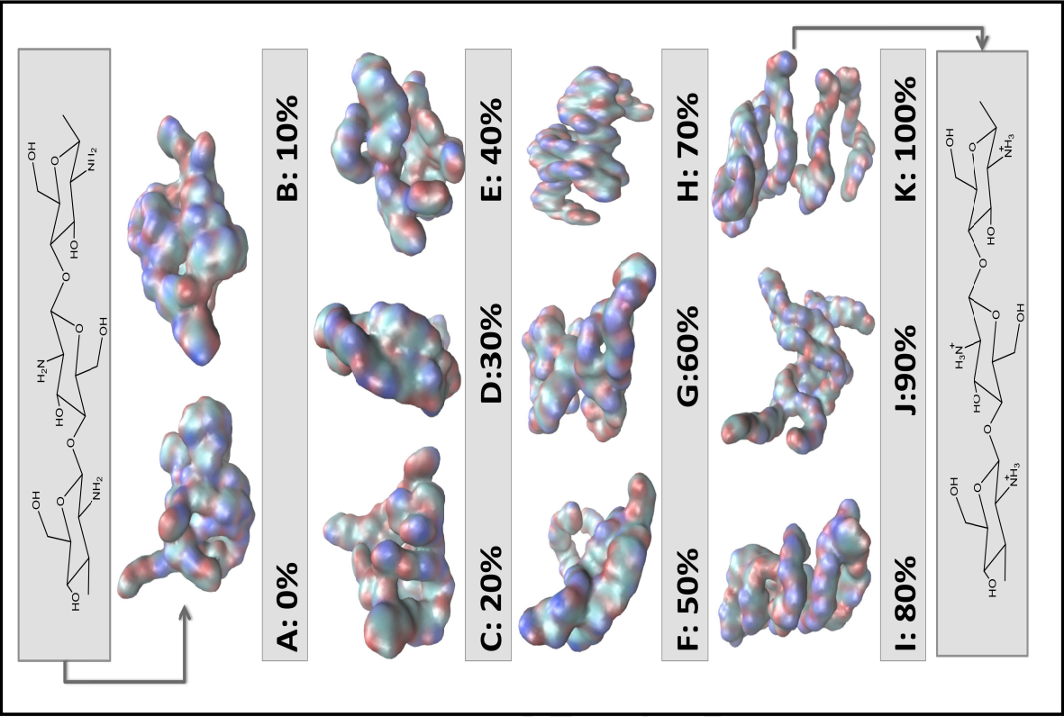

*Figure 1. Conformation of chitosan at different protonation levels, 0-100%. (Dey et al., 2016)*

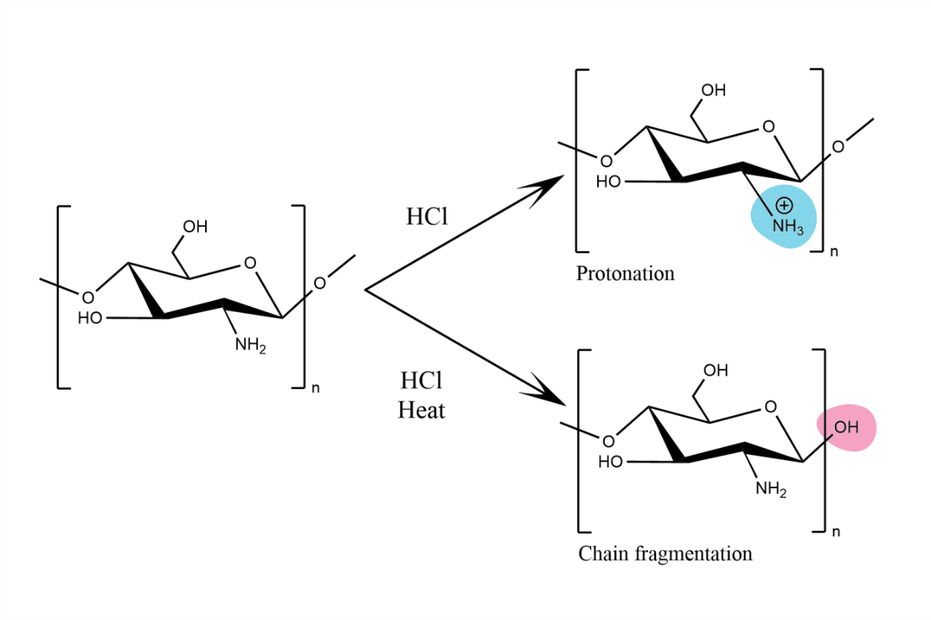  
*Figure 2. Reaction of chitosan with HCl is temperature dependent*

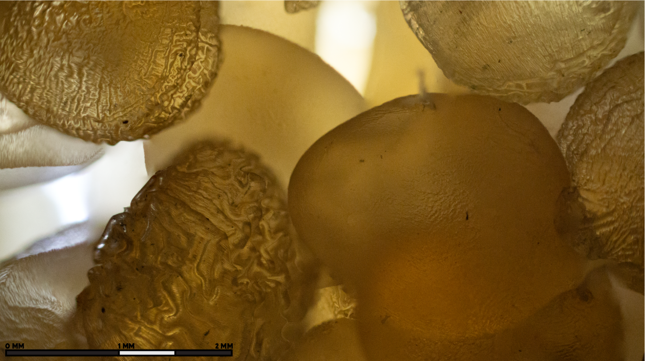*Figure 3. Examples of variety in bead morphology created under the same conditions*

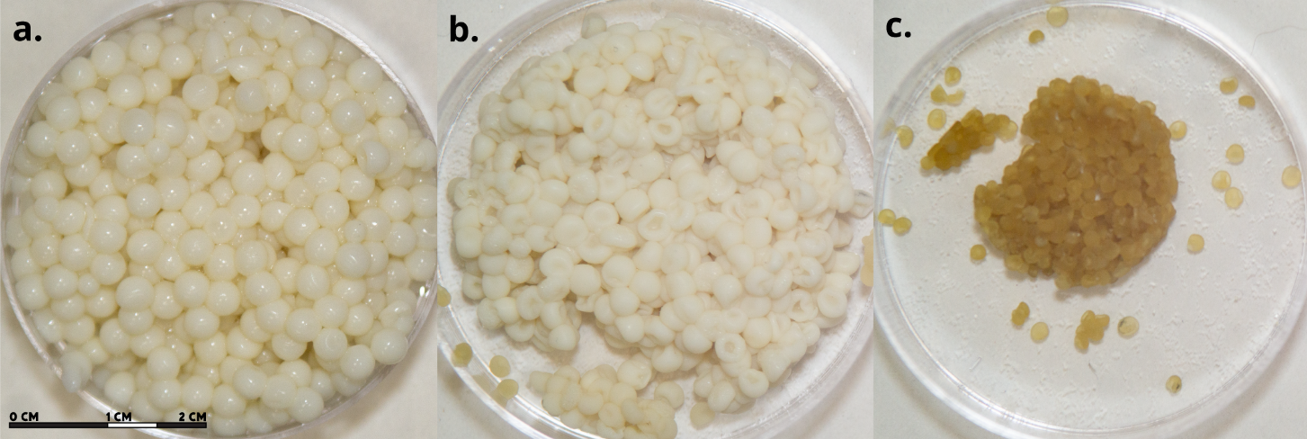*Figure 4. Chitosan beads a. non-desiccated, b. desiccated for three days, c. desiccated for ten days, created through dropwise addition and air dried*

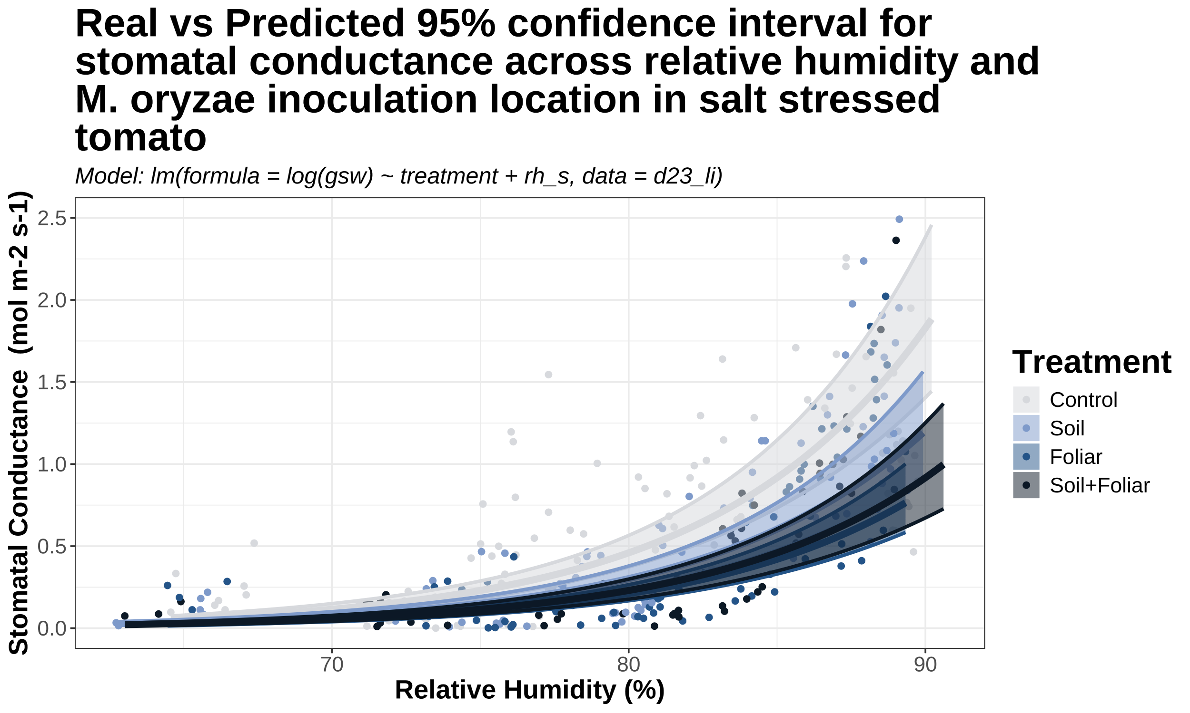

*Figure 5. Stomatal conductance (mol m-2 s-1) real vs predicted across inoculation treatments of salt stressed tomato (2023)*

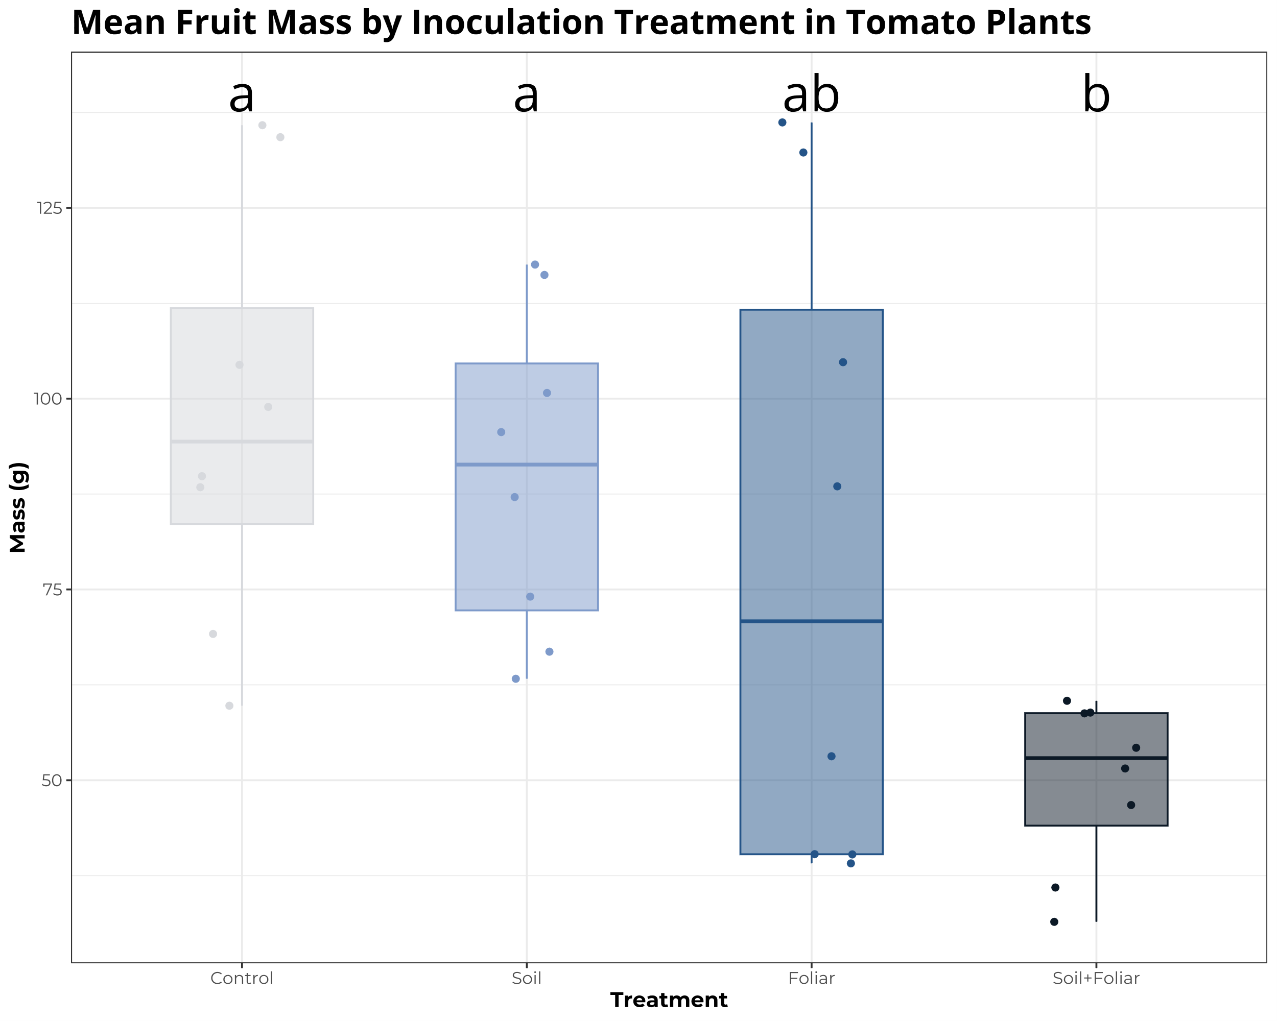

*Figure 6. Mean fruit mass (g) across inoculation treatments of salt stressed tomato (2023)*

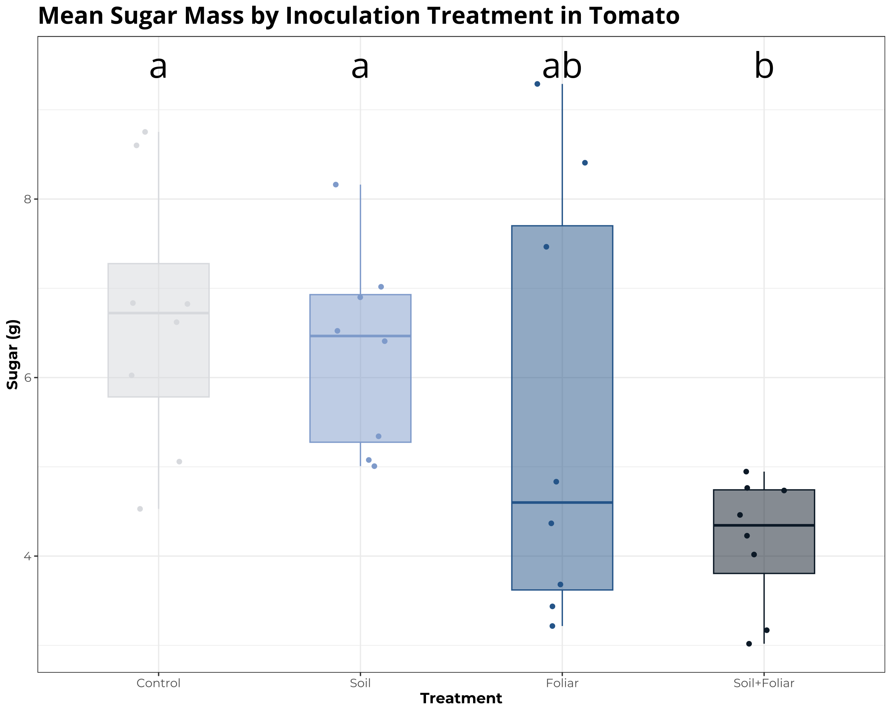

*Figure 7. Mean sugar mass per fruit (g) across inoculation treatments of salt stressed tomato (2023)*

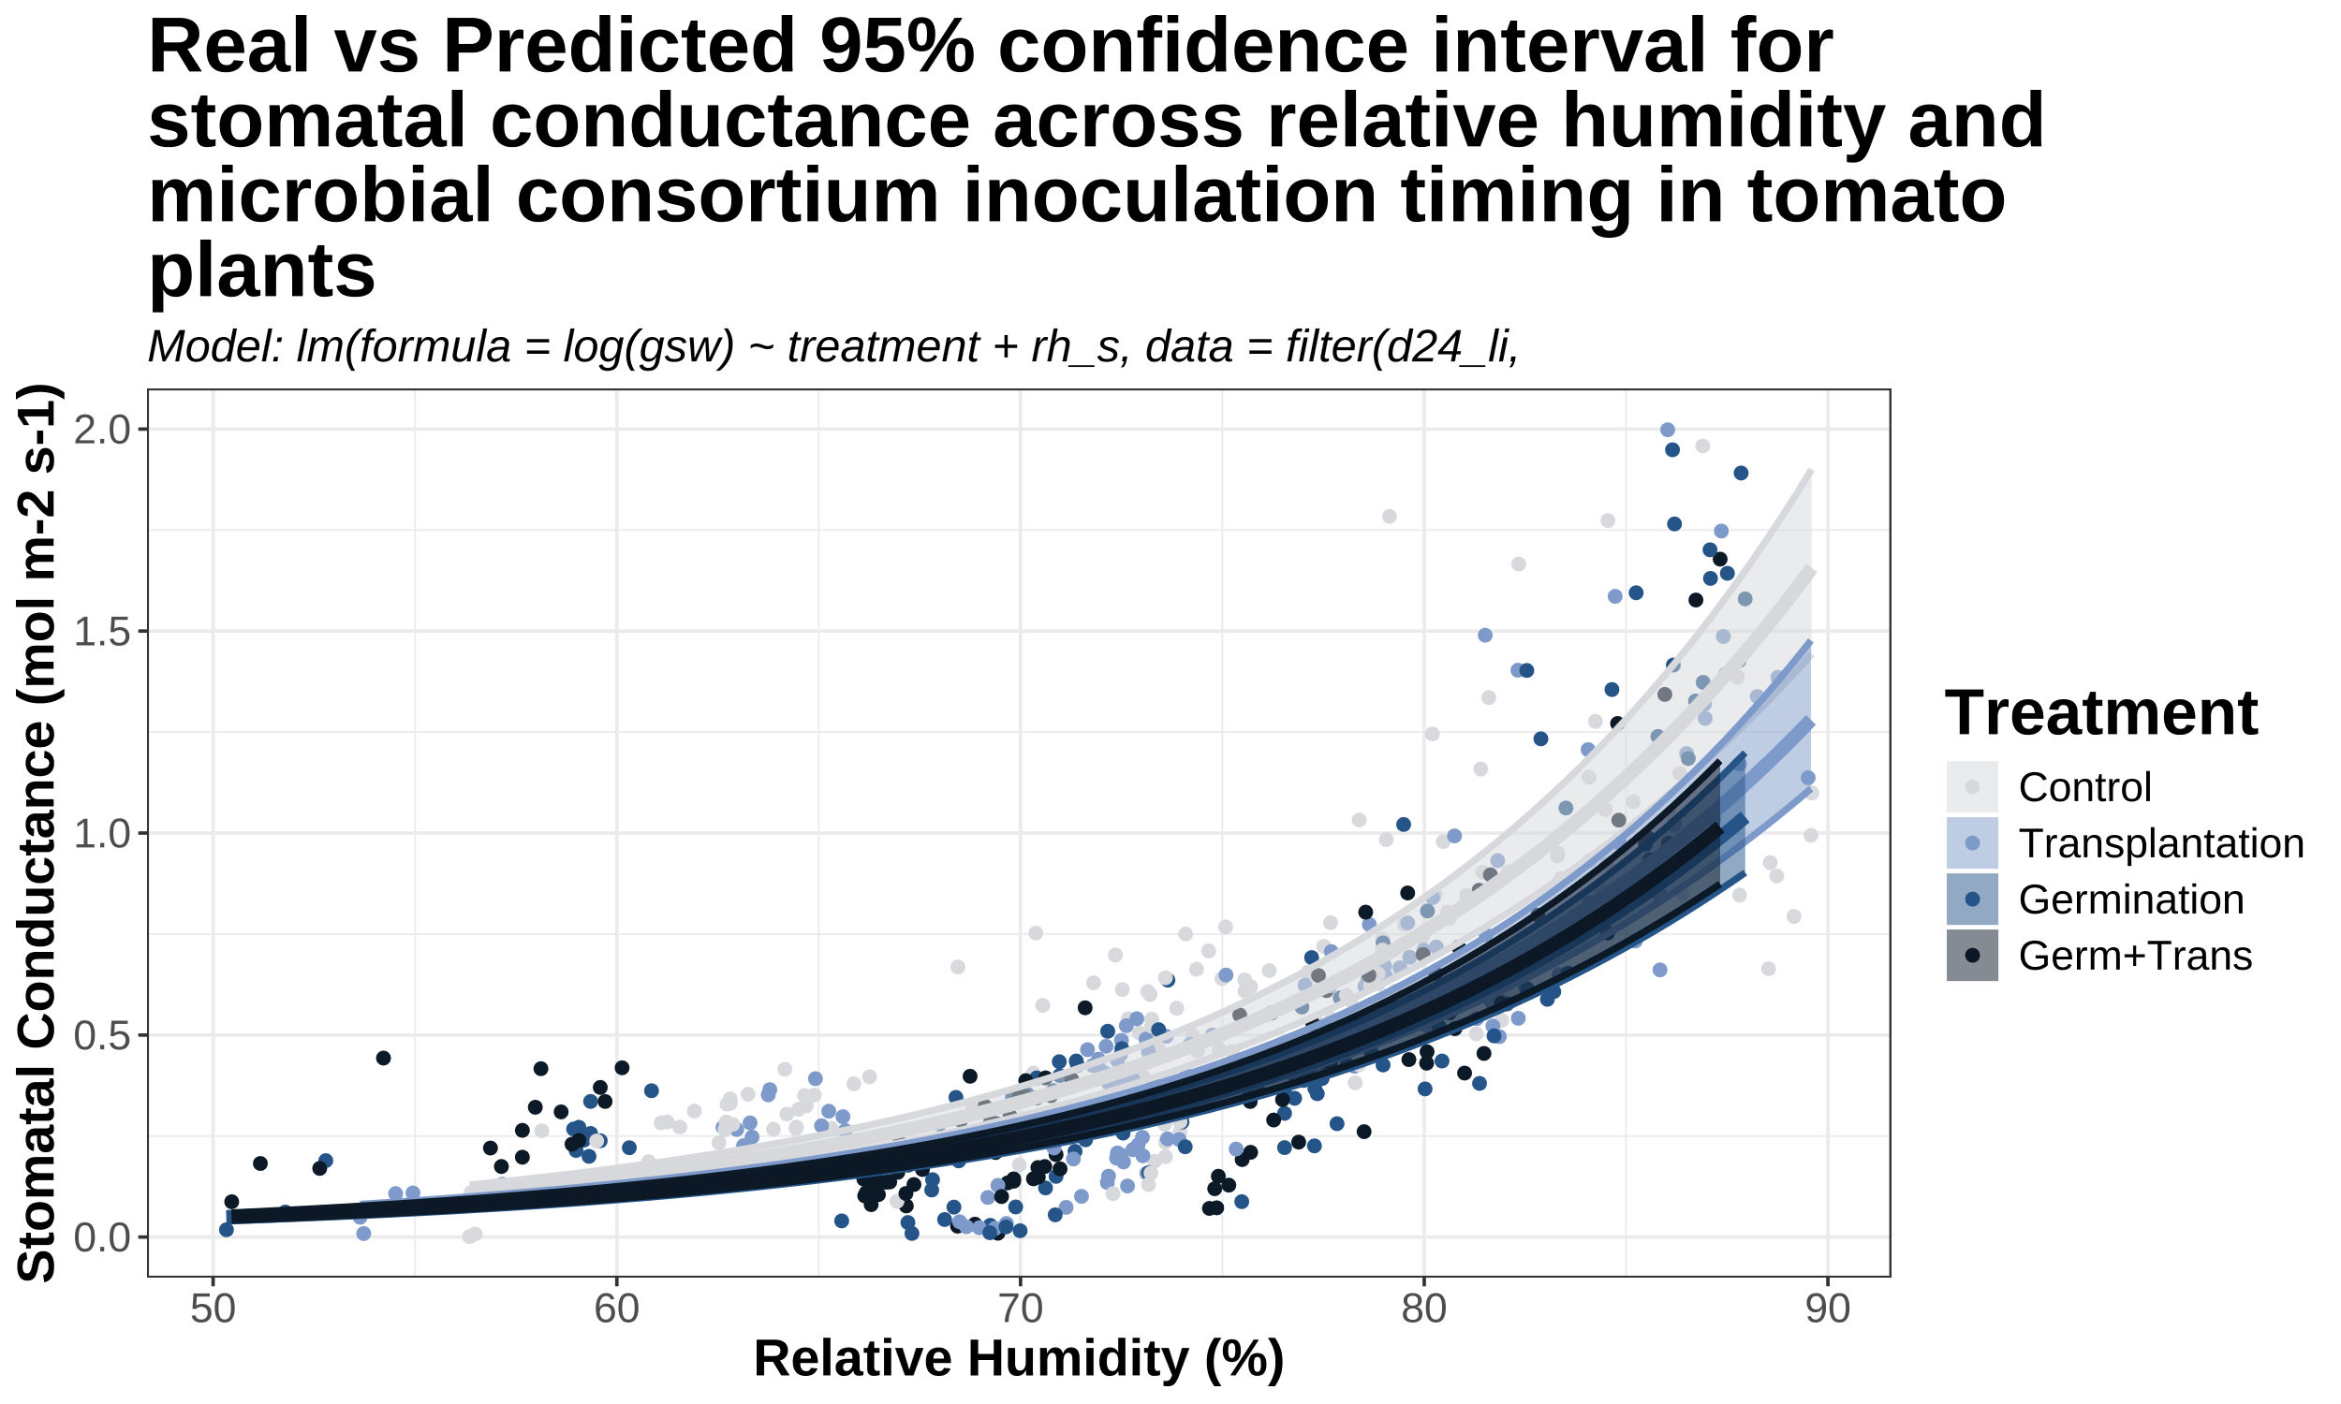

*Figure 8. Stomatal conductance (mol m-2 s-1) real vs predicted across inoculation treatments of tomato*

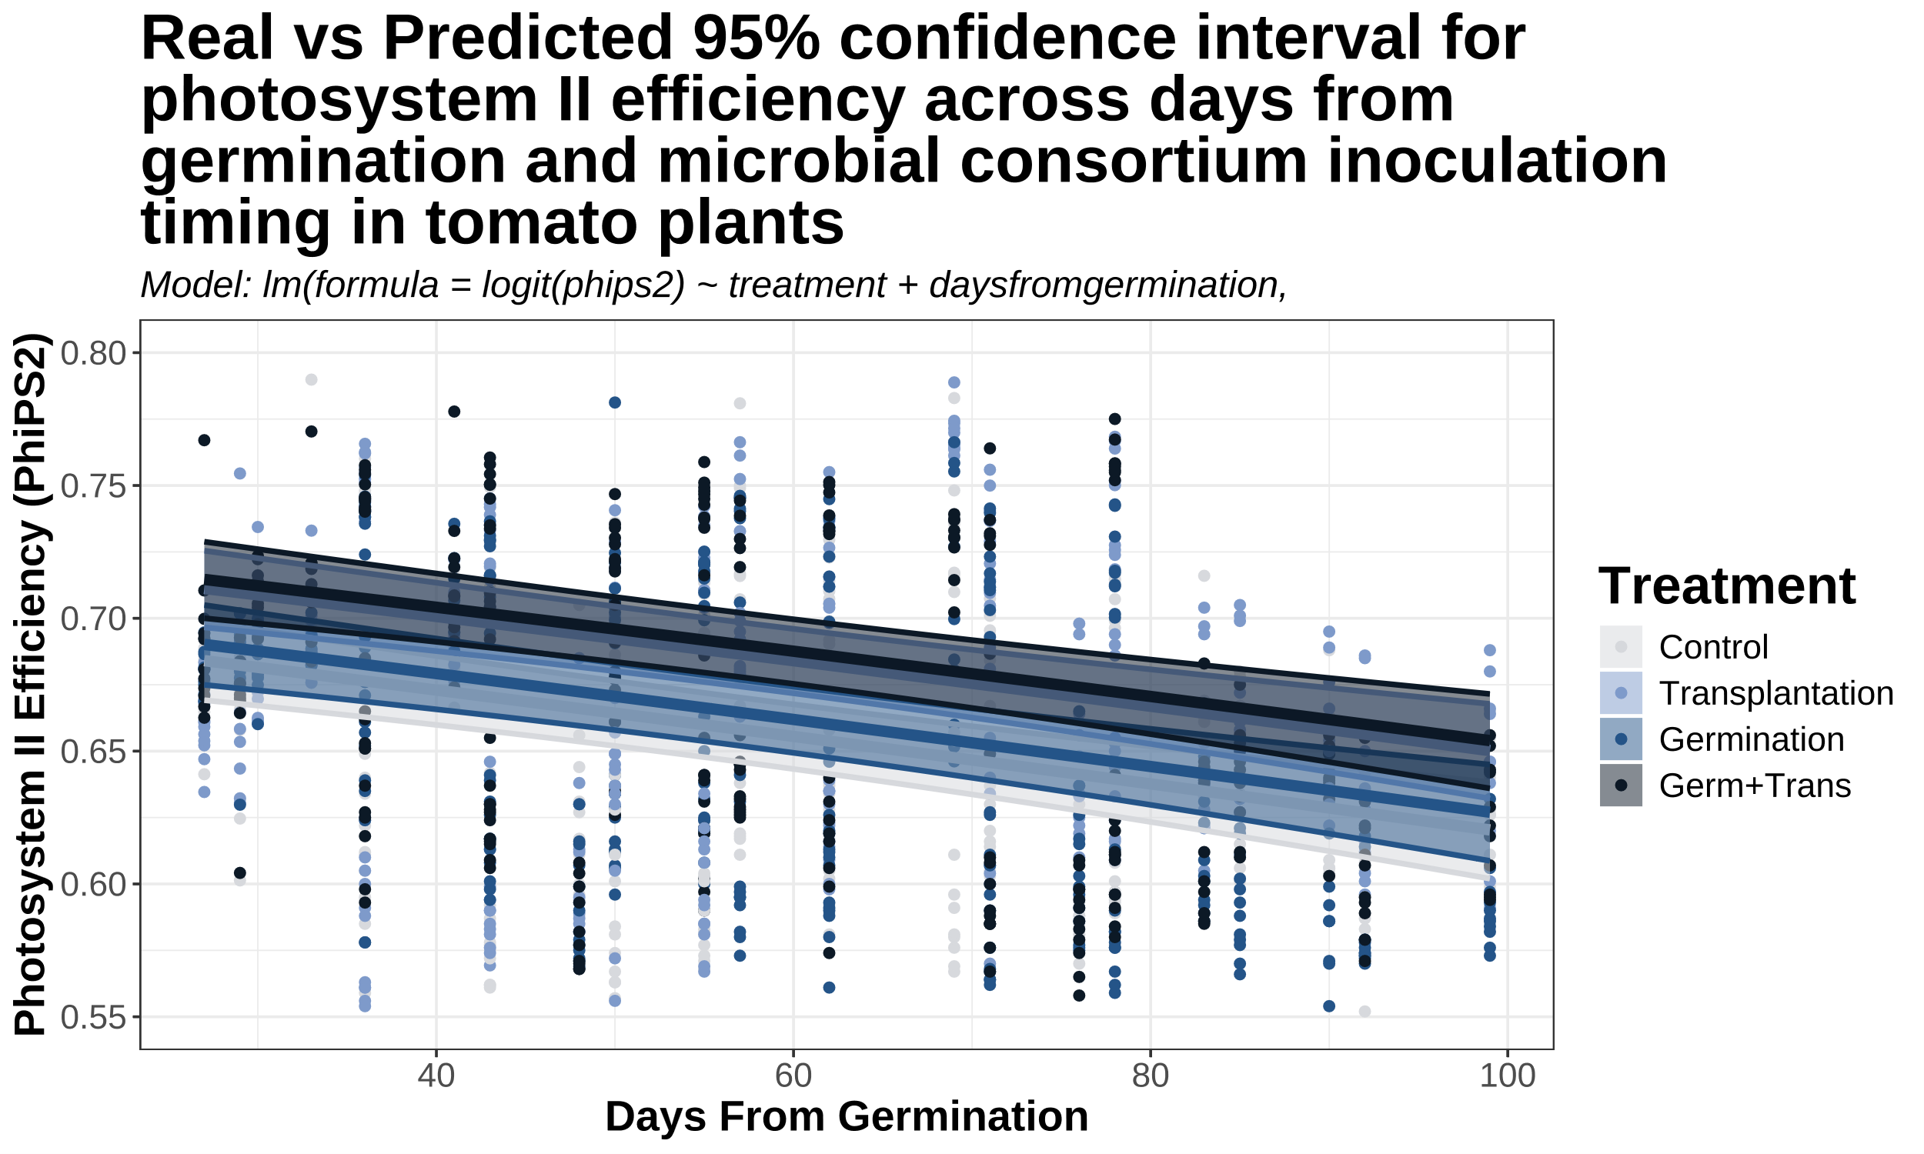

*Figure 9. PhiPS2 real vs predicted 95% confidence interval for four inoculation treatments in tomato (2024)*

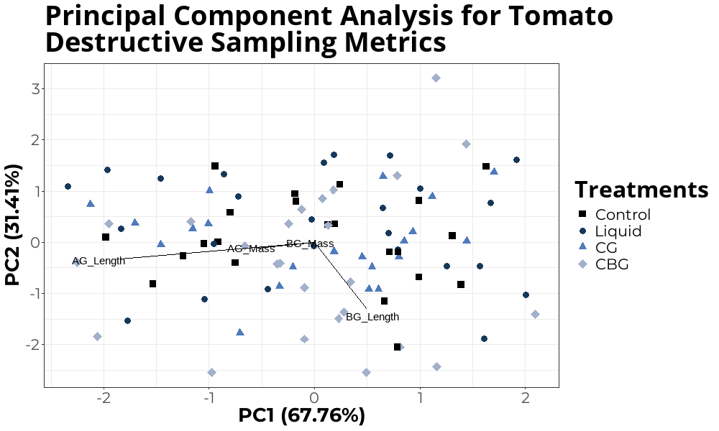

*Figure 10. PCA for tomato inoculant method trial destructive sampling data*